EXPRESSIONS OF INTEREST: AFRICA DAY OPEN ART LABS
Storytellers - rappers, singers, writers, poets, DJs, musicians:
Does art imitate life; or does life imitate art?
Share your answer as story for radio and live performance.

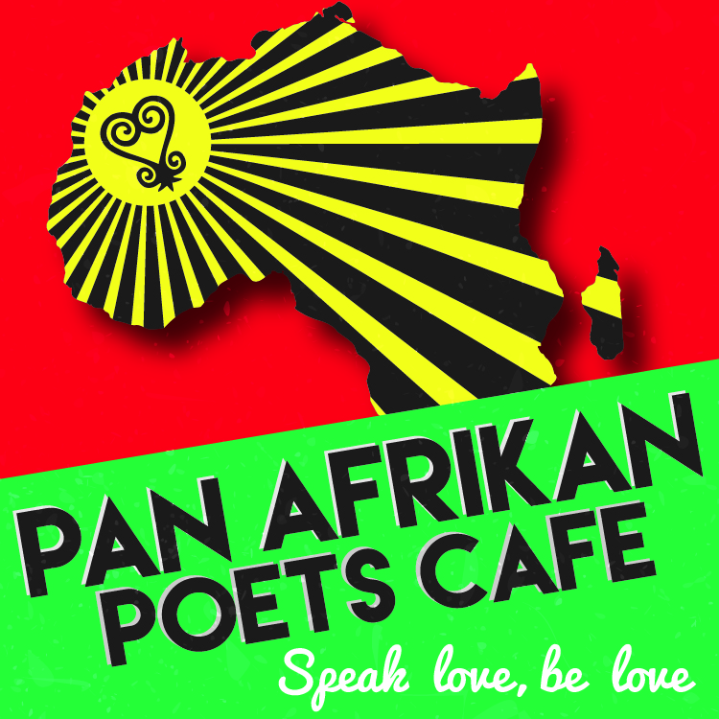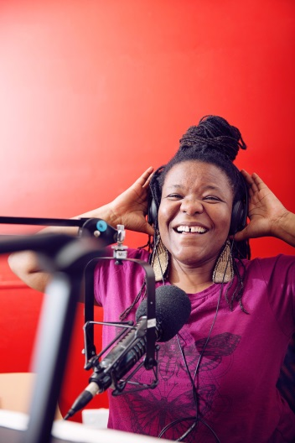

You identify as

- First Nations or Black Afrikan person aged 18 years or older.
- A budding, newly emerging or emerging storyteller.

You are available to meet up on …

- April 15 and/or April 29, 11am – 12:30pm (creative writers’ brunch).
- May 25, 26 or 27, 6pm – 7.30pm (radio skills orientation).
- May 28th, 1pm – 4.30pm (performance day).

Please email papoetscafe@gmail.com

- Your name.
- Your preferred dates: April 15 or 29; and May 25, 26 or 27.
- A 2-3 minute video or voice recording (you can use your phone) sharing your immediate answer to the question ‘Does Art Imitate Life; Or Does Life Imitate Art?’. We love answers that are based on your own life experience.

Enquiries/More Information?
- Email Sista Zai papoetscafe@gmail.com
- Attend an information session on 1 April, 11am-12.30 at 3CR Community Radio Station, 21 Smith Street, Fitzroy.

