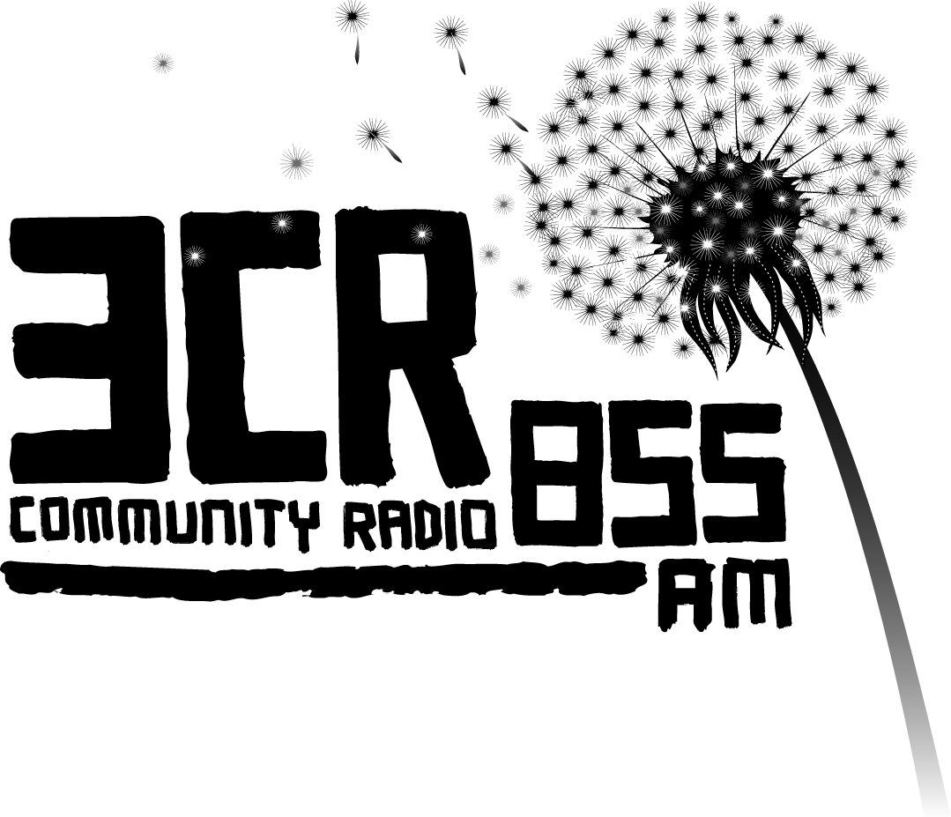
Beyond the Bars
NAIDOC Week July 4-8, 2016
www.3cr.org.au/beyondthebars

Live Prison Radio: Beyond the Bars
Beyond the Bars is a 3CR community project dedicated to giving Aboriginal and Torres Strait Islander prisoners a voice. The project features radio shows broadcast live from six Victorian prisons during NAIDOC* Week 4-8 July 2016. The broadcasts can be heard on 3CR 855AM, 3CR Digital, streaming live on 3cr.org.au, and on 3KND 1503AM.

The Beyond the Bars project first broadcast in 2002, and this year celebrates 15 years on the airwaves. It has won several awards including the Human Rights and Equal Opportunity Radio Award in 2004 and more recently the Community Broadcasting Association of Australia Contribution to Indigenous Broadcasting award in 2013.
At Loddon Prison in central Victoria, Steve, a current prisoner, says: ‘Thank you for coming in and having a wonderful time with us, and actually showing people care about brothers that are locked up. It means a lot to us.’
Beyond the Bars is one of the only live prison broadcasts in Australia and this year will give voice to over 100 men and women. The broadcasts feature stories, songs, opinions and poems from within the Dame Phyllis Frost Centre, Barwon Prison, Fulham Correctional Centre, Marngoneet Correctional Centre, Loddon Prison and Port Phillip Prison.
In a recent letter of support, the Commissioner, Corrections Victoria, states: ‘The annual prison broadcast is a valuable opportunity to connect Aboriginal prisoners with their communities during a week of national importance to Aboriginal people, NAIDOC week. The broadcast also promotes public awareness of issues that Aboriginal communities face.’
Beyond the Bars receives financial support from the Community Broadcasting Foundation, the Department of Justice and Regulation, and the City of Yarra.

BEYOND THE BARS 2016
Broadcast dates are as follows:
Mon 4 July 11am-2pm – Dame Phyllis Frost Centre (Deer Park)
Tue 5 July 11am-2pm – Barwon Prison (Lara, near Geelong)
Wed 6 July 12-2pm – Fulham Correctional Centre (near Sale, Gippsland)
Wed 6 July 2-4pm – Loddon Prison (Castlemaine)
Thu 7 July 12-3pm – Port Phillip Prison (Laverton)
Fri 8 July 11am-2pm – Marngoneet Correctional Centre (Lara, near Geelong)

*National Aboriginal and Islander Day Observance Committee
For more information: Juliet Fox, 3CR Projects Coordinator, 9419 8377 / 0417 018 147
